Outputs for Pumpkins Challenge done in R language

- Reading the file into R

→ pumpkin_data <- read.csv("D:/UoN/modules/4138 - Coding/coursework/Pumpkins/pumpkins_datasets/pumpkins_10.csv")

- Identify the heaviest pumpkin grown in any of the competitions – what variety was it? Where was it from and when was it grown?

→ pumpkin_data %>%
arrange(desc(weight_lbs)) %>%
slice(1) %>%
select(variety, city, id)

variety city id
Autumn Gold Castiglion Fiorentino 2021-P

- Write a function to change the weight in pounds (lbs) to kilograms (kg) and use this function to create a new column in your data set called weight_kg.

→ pumpkin_data$weight_kg <- pumpkin_data$weight_lbs * 0.453592

- Create another new column in your data set called weight_class. This column should be a factor with three levels: light, medium and heavy and should be based on the weight of the pumpkins. You can choose the thresholds for these three groups yourself.

→ pumpkin_data$weight_class <- ifelse(pumpkin_data$weight_lbs < 942, "light",
ifelse(pumpkin_data$weight_lbs < 1884, "medium",
"heavy"))

- Plot the relationship between the estimated weight and actual weight of the pumpkins. This can be in either lbs or kg but remember to ensure that both axes are in the same units. Colour the points in your plot based on the weight_class column that you created in question 4. Ensure the plot has appropriate axis labels and is clear and well presented. Save this plot to your computer.

→ ggplot(aes(x = est_weight, y = weight_lbs, colour = weight_class) , data = pumpkin_data)+
geom_point() +
labs(title = "Estimated Weight vs Weight in Pounds") +
xlab("Estimated Weight in Lbs") +
ylab("Weight in Lbs")

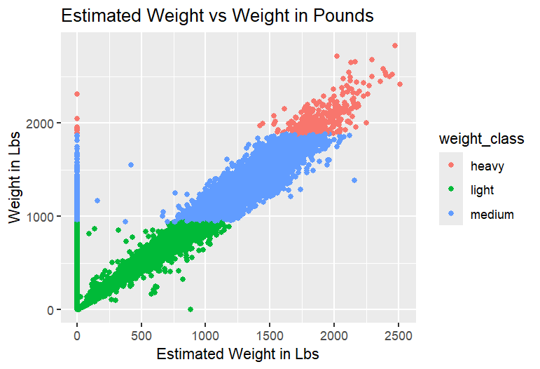
Fig 1 Plot showing relationship between estimated weight and actual weight in lbs

- Figure 1 shows positive relationship between the estimated and actual weight of pumpkins in lbs. Most pumpkins are seen to be lying in the medium and light category with some outliers.

- Filter the data to include only pumpkins from three countries of your choosing and save this filtered data set to your computer in csv format.

→ filtered_pumpkin <- pumpkin_data %>%
filter(country == "Germany" | country == "France" | country == "Austria")

- Summarise your filtered dataset from question 6:
a. Identify the mean weight of pumpkins for each of your three countries. Which country had the highest mean pumpkin weight?

→ filtered_pumpkin %>%
group_by(country) %>%
summarise_at(vars(weight_lbs), mean) %>%
arrange(desc(weight_lbs))

country weight_lbs
<chr> <dbl>
1 France 674.
2 Germany 601.
3 Austria 578.

b. Identify the mean weight for each variety of pumpkin for each of your countries. Which variety in which country had the lowest mean weight?

→ filtered_pumpkin %>%
group_by(country, variety) %>%
summarise(mean_weight = mean(weight_lbs)) %>%
arrange(country, mean_weight)

→ filtered_pumpkin %>%
group_by(variety, country) %>%
summarise_at(vars(weight_lbs), mean) %>%
arrange(weight_lbs)

variety country weight_lbs
<chr> <chr> <dbl>
1 Wolf France 379
2 Connecticut Field Austria 430
3 Champion Austria 489

- Using your filtered data set from question 6, plot pumpkin weight distributions (in either lbs or kg) for your three countries as a boxplot. Ensure the plot has appropriate axis labels and is clear and well presented. Save this boxplot to your computer.

→ ggplot(aes(x = country, y = weight_lbs), data = filtered_pumpkin)+
geom_boxplot(fill = 'lightblue')+
labs(title = "Pumpkin Weight Distribution") +
xlab("Countries") +
ylab("Weight in Lbs")

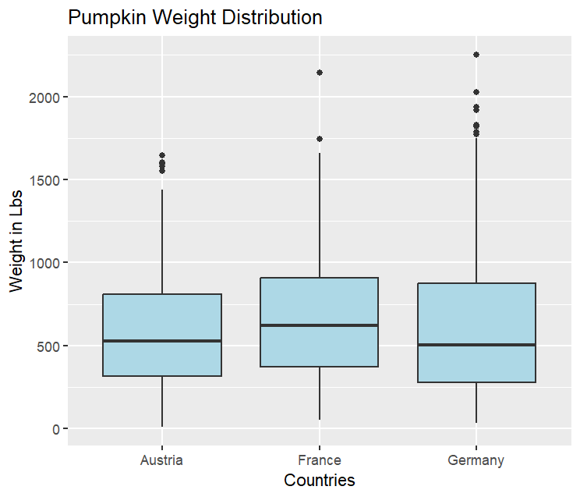
Fig 2 Pumpkin weight distributions for the selected three countries

- Fig 2 Shows boxplot for Austria, France and Germany with France having the highest median weight out of the three countries. Germany shows the most number of outliers which indicates some very heavy pumpkins.

- Redraw your plot from question 8 as a facet plot showing the data from each variety of pumpkin as a separate sub-plot. Save this plot to your computer.

→ ggplot(aes(x = country, y = weight_lbs, colour = country), data = filtered_pumpkin)+
geom_boxplot()+
facet_wrap(~variety) +
scale_colour_manual(values = c(
'Austria' = 'turquoise',
'France' = 'pink',
'Germany' = 'darkolivegreen'
)) +
labs(title = "Pumpkin Weight Distribution Across Varieties for 3 Countries") +
xlab("Countries") +
ylab("Weight in Lbs")

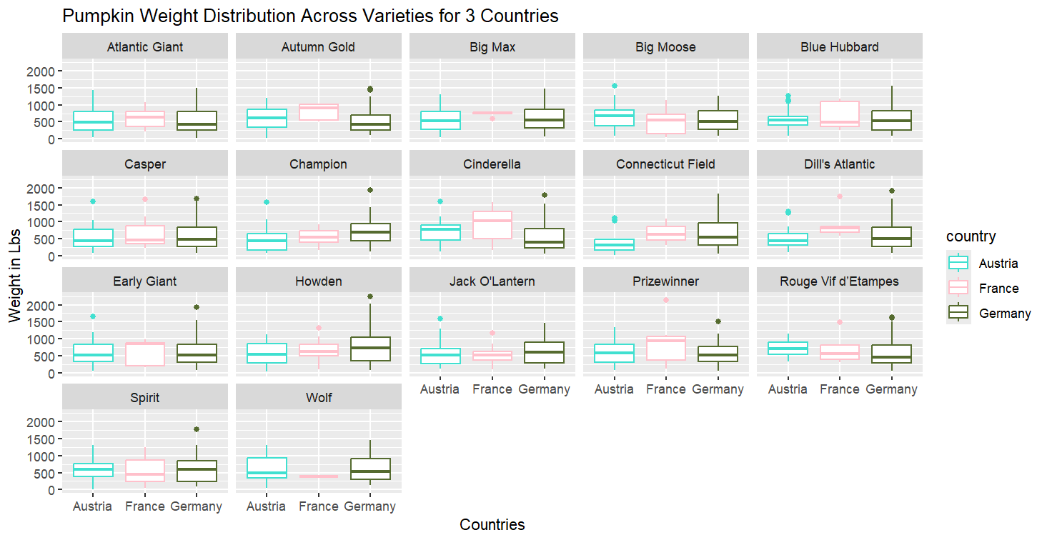

Fig 3 Faceted plot showing the pumpkin weight distribution across each variety for the three countries

- This faceted boxplot shows that across most varieties, France and Germany tend to have higher median weights than Austria, with Germany often showing the heaviest outliers.

